Jack red/black

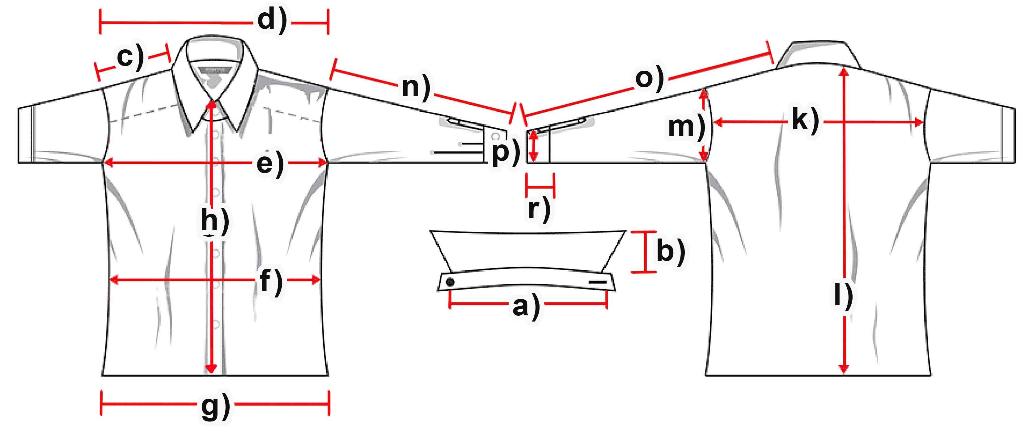

Measure (cm) | S | M | L | XL | XXL | 3XL
a) Collar width | 38,5 | 41 | 42 | 43,5 | 45,5 | 47
b) Collar height | 7 | 7 | 7 | 7 | 7 | 7
c) Shoulder | 17,5 | 18 | 18,5 | 19 | 20 | 22
d) Shoulders total | 48,5 | 50,5 | 53 | 55 | 57,5 | 59,5
e) Chest | 54 | 58 | 62,5 | 65,5 | 70 | 73
f) Waist | 52,5 | 56 | 60 | 62,5 | 67 | 70
g) Hem | 54,5 | 59 | 63 | 65,5 | 71 | 73,5
h) Placket | 63,5 | 65,5 | 68 | 68 | 70 | 70
k) Back width | 45,5 | 47,5 | 50 | 52 | 54 | 56,5
l) Hull lenght | 72,5 | 75 | 78 | 78 | 80,5 | 80,5
m) Armhole | 26 | 27 | 28 | 29 | 30 | 31
n) Arm length | 61,5 | 62 | 65 | 65 | 68 | 68
o) Arm + Shoulder | 79 | 81 | 83,5 | 85 | 88 | 90
p) Cuff width | 11 | 12 | 12 | 12,5 | 13 | 13,5
r) Cuff height | 18 | 18 | 18 | 18 | 18 | 18

