YUKON
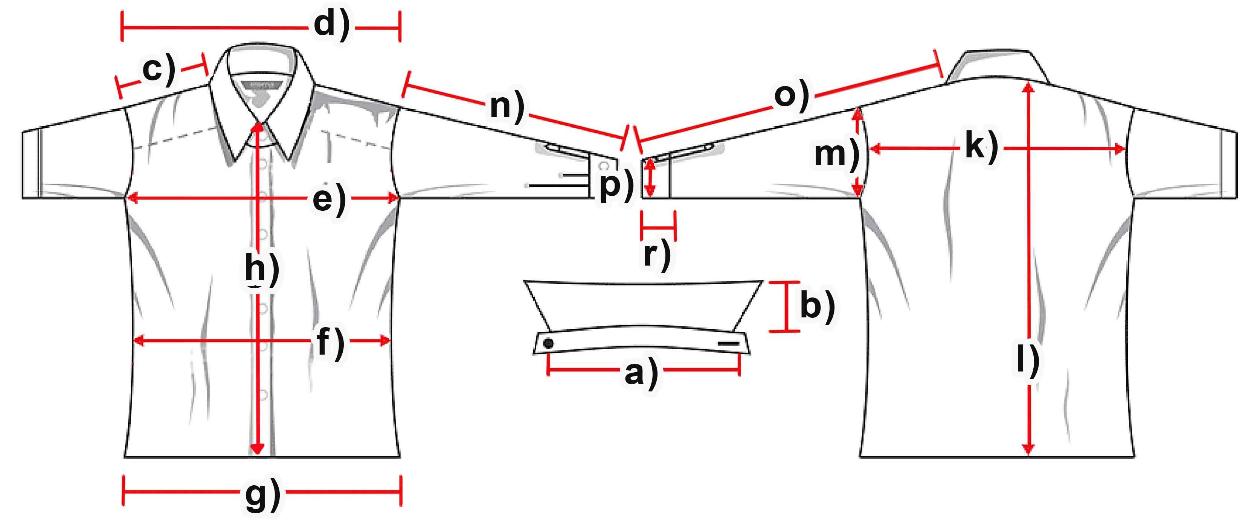

Measure (cm) | XS | S | M | L | XL | XXL | 3XL
a) Collar width
b) Collar height |  | 7,5 | 7,5 | 8 | 7,5 | 8 | 8
c) Shoulder |  | 17,5 | 17,5 | 17,5 | 18 | 18,5 | 18,5
d) Shoulders total |  | 50 | 52,5 | 54 | 55,5 | 55,5 | 59,5
e) Chest |  | 59 | 61 | 63,5 | 65,5 | 67 | 69
f) Waist |  | 57 | 60,5 | 62,5 | 64,5 | 65 | 67,5
g) Hem |  | 58,5 | 61,5 | 64 | 65 | 68 | 69
h) Placket |  | 69,5 | 59 | 59 | 71 | 71 | 72
k) Back width |  | 47,5 | 50 | 51 | 52,5 | 53 | 55
l) C.B length |  | 76,5 | 77 | 78 | 80 | 80,5 | 81,5
m) Armhole |  | 28,5 | 29 | 32 | 32,5 | 32 | 34
n) Arm length |  | 61,5 | 62,5 | 65,5 | 65,5 | 65,5 | 66,5
o) Arm + Shoulder |  | 79 | 80 | 83 | 83,5 | 84 | 85
p) Cuff width |  | 14,5 | 15,5 | 15,5 | 17 | 16 | 17
r) Cuff height

