ACOMA

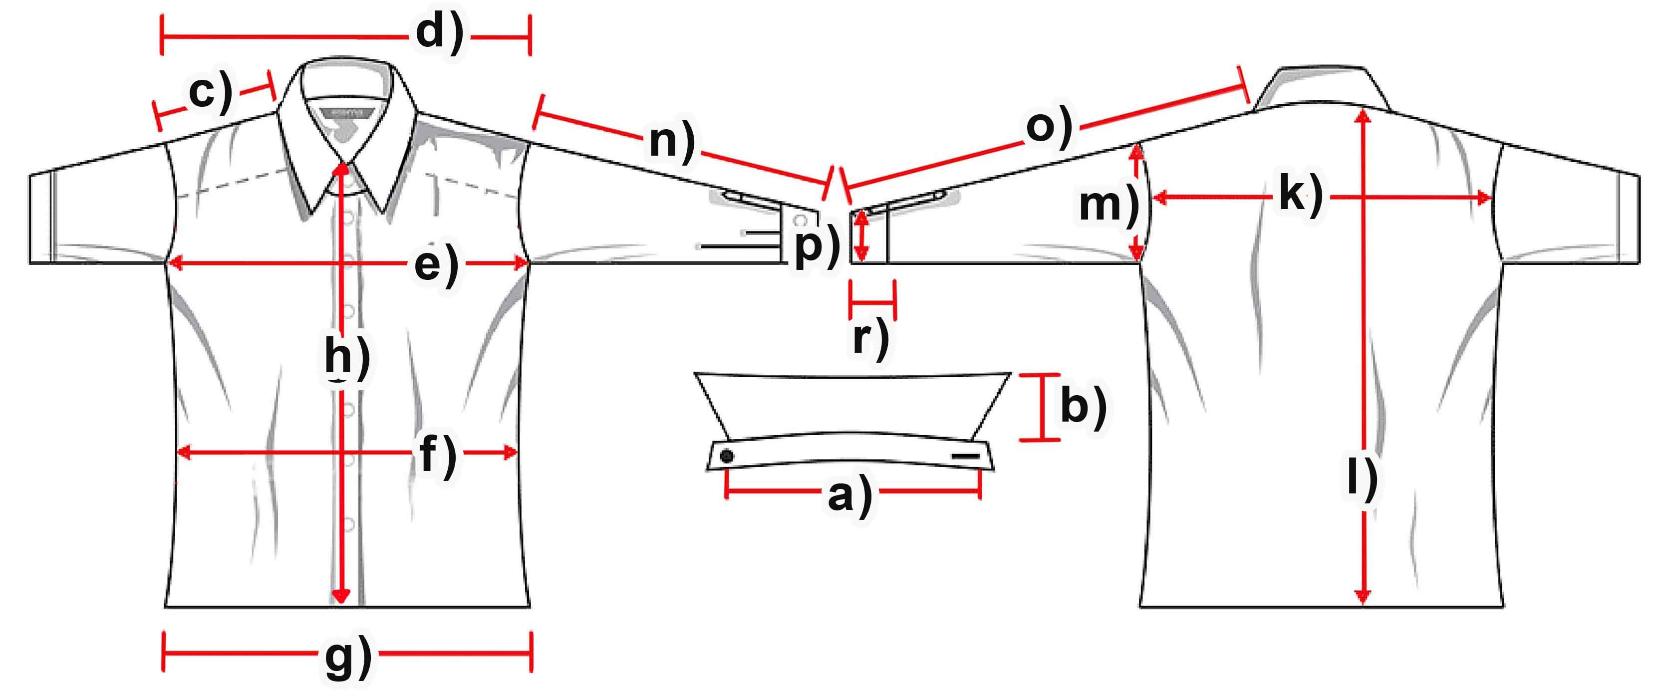

Measure (cm) | S | M | L | XL | XXL | 3XL
a) Collar width
b) Collar height | 4 | 4 | 4 | 4 | 4 | 4,5
c) Shoulder | 12 | 12,5 | 13 | 13,5 | 14 | 14,5
d) Shoulders total | 41 | 42 | 43 | 43,5 | 44 | 48
e) Chest | 45 | 48,5 | 50 | 53,5 | 55 | 60,5
f) Waist | 41,5 | 44 | 46 | 49 | 52 | 56
g) Hem | 46 | 47 | 48 | 51,5 | 54 | 58,5
h) Placket | 46 | 47,5 | 49 | 50 | 51 | 52
k) Back width | 37,5 | 39,5 | 40 | 41,5 | 42,5 | 44
l) Hull lenght | 53,5 | 54,5 | 55,5 | 57 | 58 | 58,5
m) Armhole | 24 | 25 | 26 | 26,5 | 27 | 29
n) Arm length | 62 | 63 | 64 | 65 | 66 | 66,5
o) Arm + Shoulder | 75 | 75 | 77,5 | 78,5 | 80 | 81
p) Cuff width | 12 | 12 | 12,5 | 13 | 13,5 | 14,5
r) Cuff height | 6 | 6 | 6 | 6 | 6,5 | 6,5

