ANTHONY

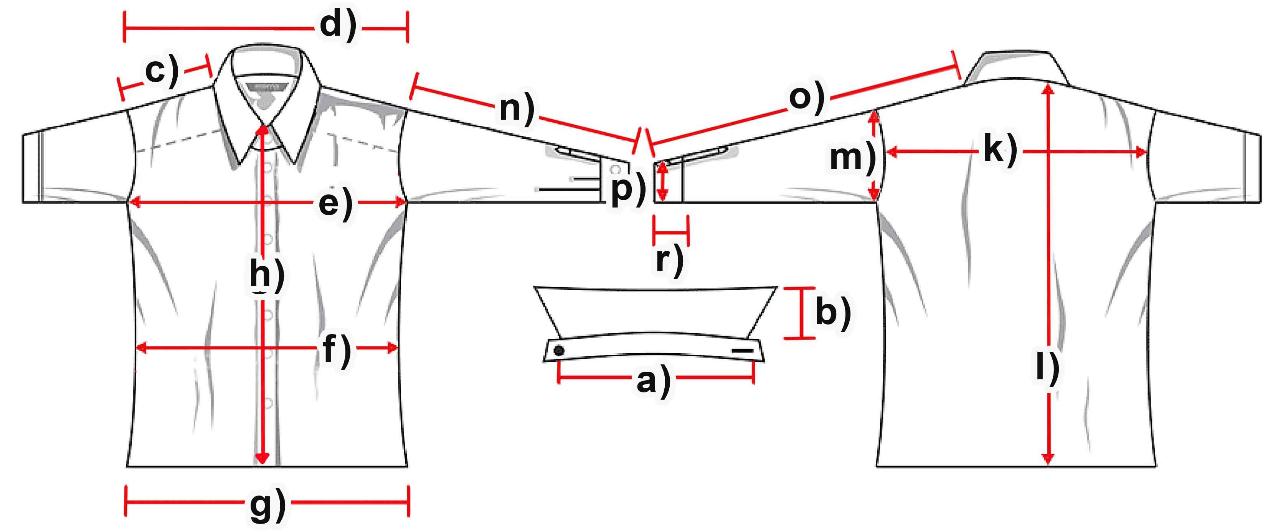

Measure (cm) | S | M | L | XL | XXL | 3XL
a) Collar width | 38 | 40 | 42 | 44 | 46 | 47,5
b) Collar height | 8 | 8 | 8 | 8 | 8 | 8
c) Shoulder | 18 | 19,5 | 20 | 20,5 | 21,5 | 22,5
d) Shoulders total | 50,5 | 52,5 | 55,5 | 57 | 60 | 62,5
e) Chest | 54 | 58,5 | 62 | 66 | 70,5 | 74
f) Waist | 53 | 56,5 | 60 | 64 | 67,5 | 70,5
g) Hem | 55 | 59 | 63 | 67 | 70,5 | 74
h) Placket | 65,5 | 67,5 | 69 | 70,5 | 71 | 73
k) Back width | 48 | 51 | 53,5 | 55 | 58,5 | 60,5
l) Hull lenght | 73,5 | 74 | 76 | 77,5 | 80 | 81,5
m) Armhole | 25,5 | 27 | 28 | 29 | 30 | 31
n) Arm length | 59 | 60,5 | 62 | 63,5 | 64 | 65
o) Arm + Shoulder | 77 | 80 | 82 | 84 | 86 | 88
p) Cuff width | 11,5 | 11,5 | 12 | 12,5 | 13 | 13,5
r) Cuff height | 19 | 19 | 19 | 19 | 19 | 19

