BOSTON

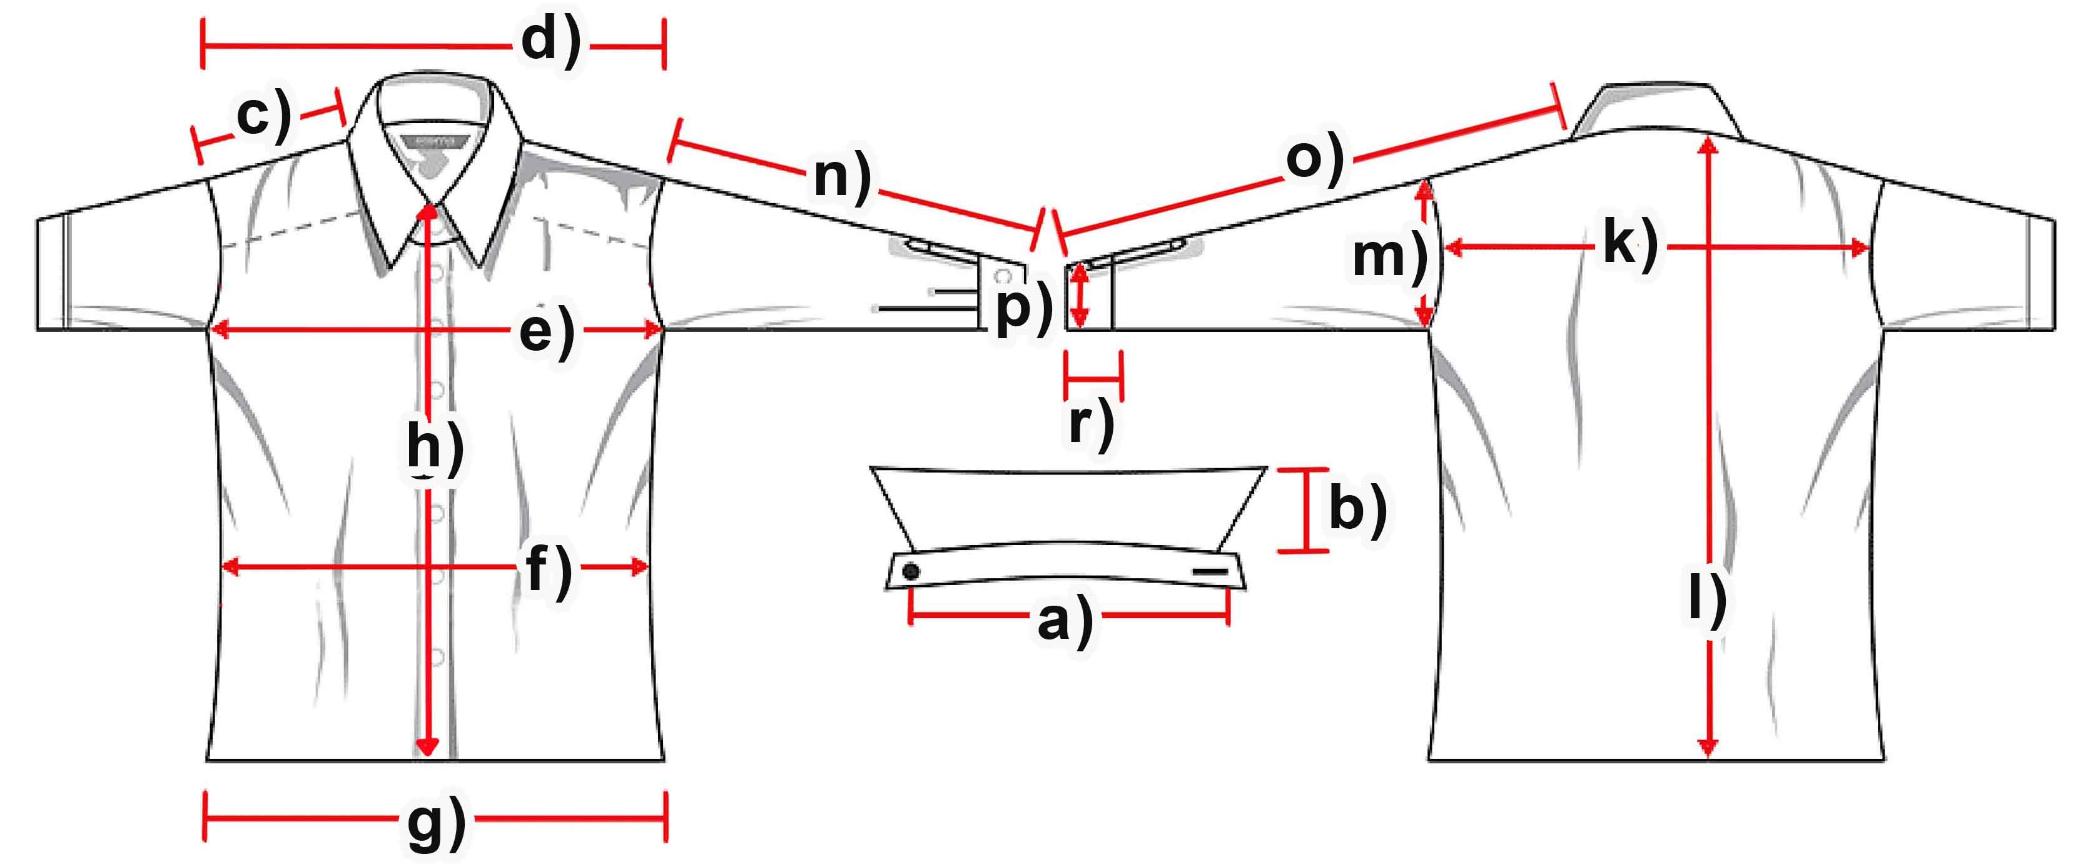

Mass (cm) | S | M | L | XL | XXL | 3XL
a) collar width | 38 | 39,8 | 41,6 | 43,7 | 45,5 | 47,5
b) collar height
c) shoulder | 17 | 17,8 | 18,6 | 19,4 | 20,2 | 21
d) shoulder complete
e) chest | 54 | 58 | 62 | 66 | 70 | 74
f) waist | 53 | 56,5 | 60 | 63,5 | 67 | 70,5
g) hemline | 55 | 58,8 | 62,6 | 66,4 | 70,2 | 74
h) button-facing | 66 | 67,5 | 69 | 70,5 | 72 | 73,5
k) back
l) length | 74 | 75,4 | 76,8 | 78,2 | 79,6 | 81
m) armhole | 26 | 27 | 28 | 29 | 30 | 31
n) armlength | 61 | 62,2 | 63,4 | 64,6 | 65,8 | 67
o) arm + shoulder | 78 | 80 | 82 | 84 | 86 | 88
p) cuff width | 11,0 | 11,5 | 12,0 | 12,5 | 13,0 | 13,5
r) cuff height

