FARMER

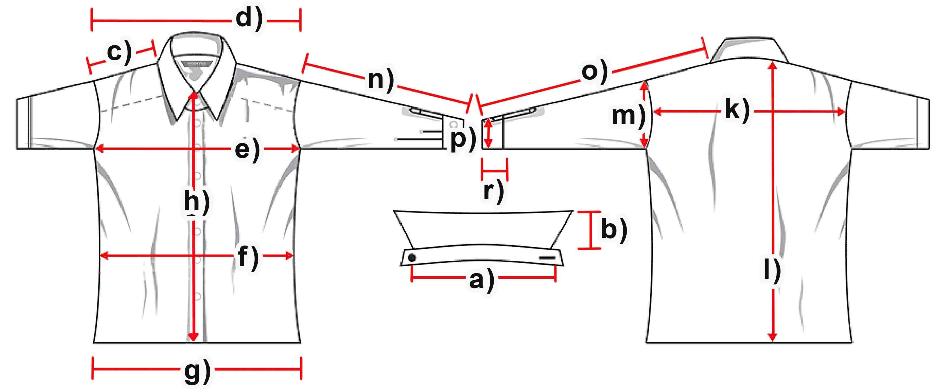

Mass (cm) | S | M | L | XL | XXL | 3XL
a) collar width
b) collar height | 3 | 3 | 3 | 3 | 3 | 3
c) shoulder | 17 | 18 | 19 | 20 | 21 | 22
d) shoulder complete | 46,5 | 48,5 | 51,5 | 54 | 56,5 | 59,5
e) chest | 54 | 58 | 61,5 | 65 | 69 | 73,5
f) waist | 52,5 | 55,5 | 58,5 | 63 | 66,5 | 70
g) hemline | 54 | 57,5 | 62 | 65,5 | 71 | 74,5
h) button-facing | 35 | 35 | 35 | 35 | 35 | 35
k) back | 45,5 | 47,5 | 50,5 | 52,5 | 55 | 58
l) length | 73,5 | 75,5 | 76 | 78,5 | 80 | 81
m) armhole | 24,5 | 25 | 26,5 | 28,5 | 29 | 31,5
n) armlength | 61,5 | 62,5 | 63 | 64 | 65 | 67,5
o) arm + shoulder | 78,5 | 81 | 82 | 83,5 | 86 | 89
p) cuff width | 11,5 | 11,5 | 12 | 12 | 12,5 | 12,5
r) cuff height | 7,5 | 7,5 | 7,5 | 7,5 | 7,5 | 7,5

