FULL HOUSE

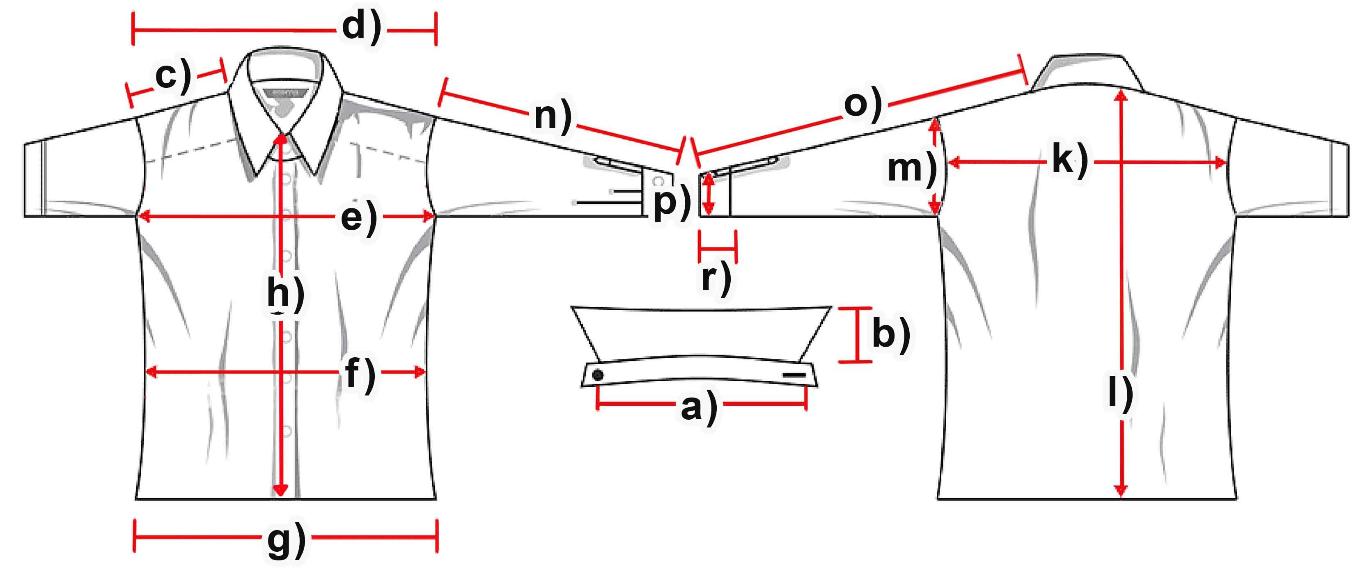

Mass (cm) | S | M | L | XL | XXL | 3XL
a) collar width | 14 | 15 | 15 | 15 | 15 | 15
b) collar height | 7,5 | 7,5 | 7,5 | 7,5 | 8 | 8
c) shoulder | 10 | 10,5 | 11 | 11,5 | 11,5 | 12
d) shoulder complete | 35 | 36 | 37,5 | 38,5 | 40,5 | 41,5
e) chest | 51 | 53 | 56 | 59 | 62,5 | 65,5
f) waist | 49,5 | 52,5 | 55,5 | 58 | 61,5 | 64,5
g) hemline | 51 | 52,5 | 56 | 58,5 | 62 | 64,5
h) button-facing | 28,5 | 29 | 29,5 | 31 | 32 | 33
k) back | 64,5 | 66,5 | 67,5 | 69,5 | 71 | 72
l) length | 57 | 58,5 | 60 | 61,5 | 63,5 | 64
m) armhole | 28,5 | 29 | 29,5 | 30 | 30,5 | 31

