Spencer

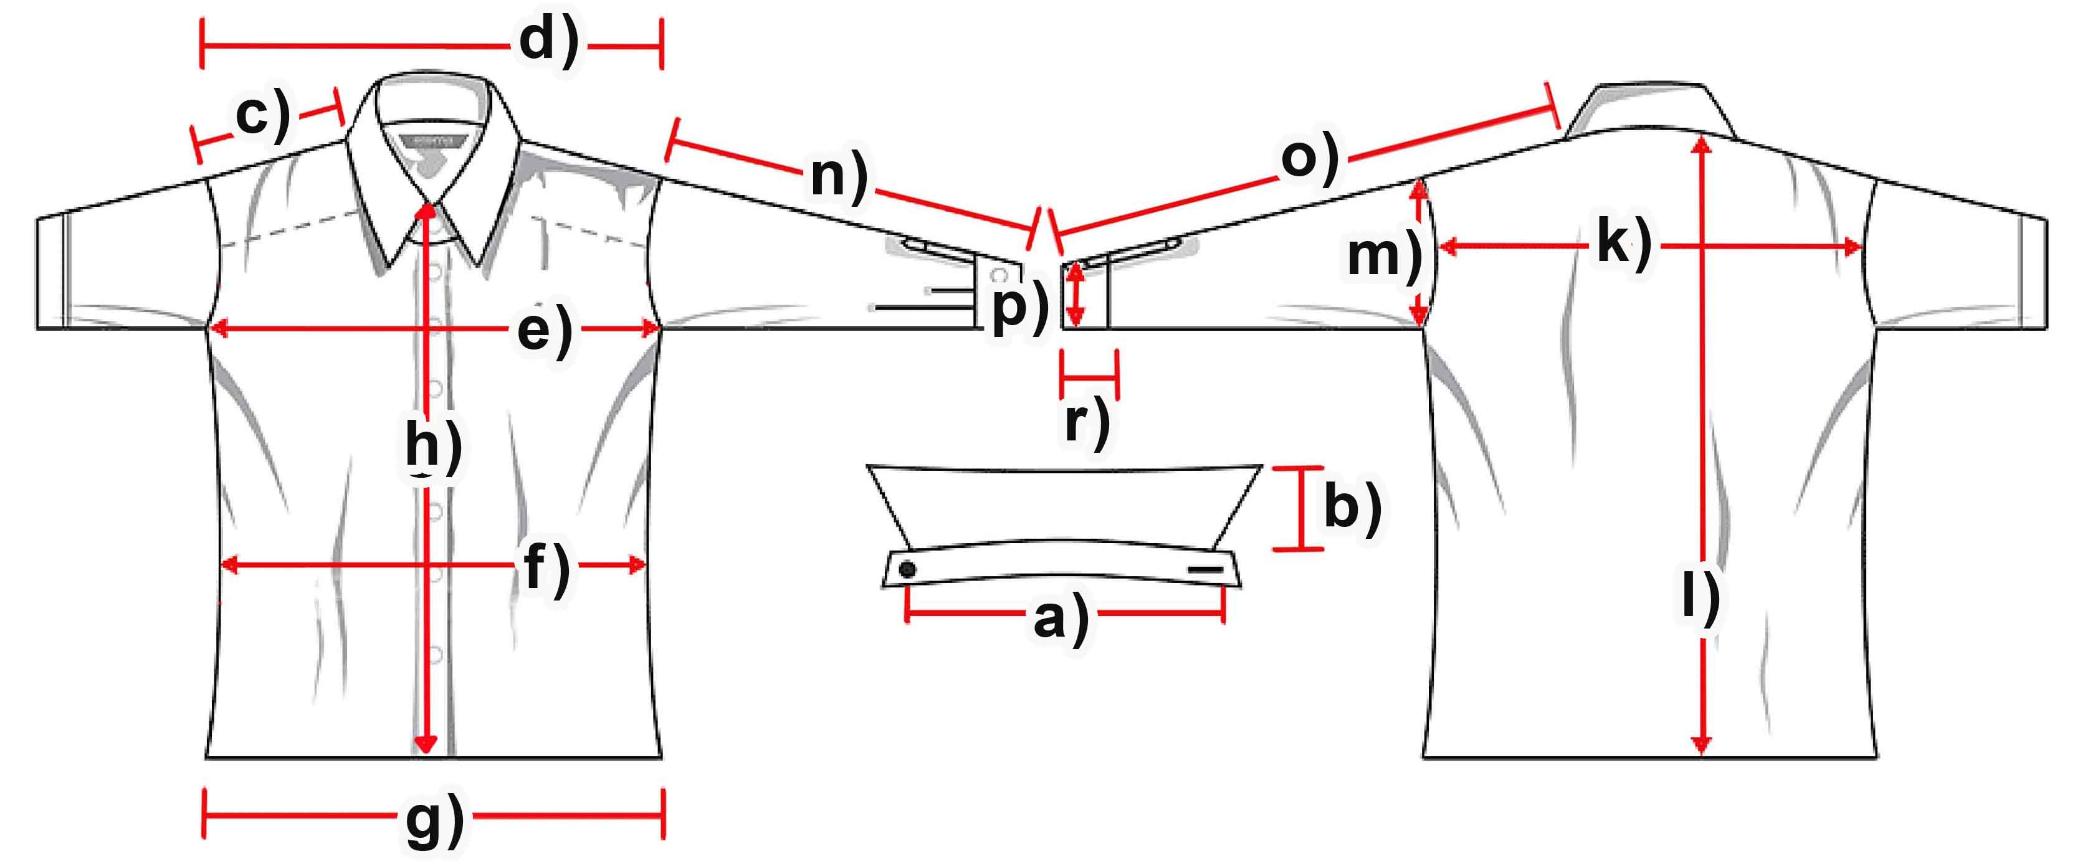

Measure (cm) | S | M | L | XL | XXL | 3XL
a) Collar width | 37 | 39,5 | 42 | 43 | 45 | 47,5
b) Collar height | 5,5 | 5,5 | 5,5 | 5,5 | 5,5 | 5,5
c) Shoulder | 17 | 18 | 19 | 20 | 20,5 | 21,5
d) Shoulders total | 45,5 | 48 | 51 | 53 | 56 | 58
e) Chest | 54,5 | 58 | 62 | 65,5 | 69,5 | 73
f) Waist | 53,5 | 56,5 | 59,5 | 63,5 | 67 | 70,5
g) Hem | 54,5 | 59,5 | 63 | 66,5 | 72 | 74,5
h) Placket | 66 | 67 | 68 | 70 | 71 | 72
k) Back width | 44,5 | 46 | 49,5 | 52 | 54,5 | 57
l) Hull lenght | 74 | 75 | 77 | 78,5 | 80 | 82
m) Armhole | 25 | 26 | 27 | 28 | 29 | 30,5
n) Arm length | 62 | 63 | 64 | 64,5 | 65 | 66
o) Arm + Shoulder | 79 | 80,5 | 83 | 84,5 | 85,5 | 87,5
p) Cuff width | 11 | 11,3 | 11,5 | 12 | 12 | 12
r) Cuff height | 8 | 8 | 8 | 8 | 8 | 8

